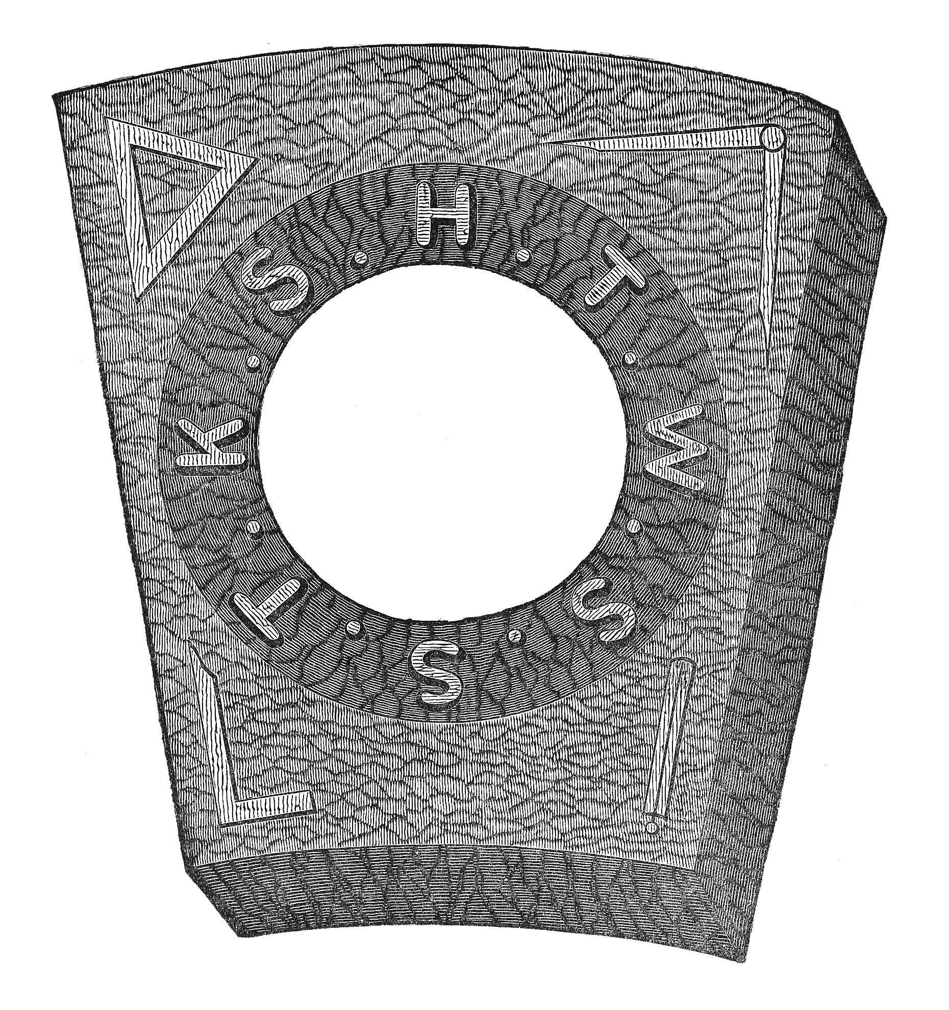

Mark of Companion
Description:
Recorded:
When Marked: When Exalted:

